Document Name
Document Type
Author or Authors
Project
Project Requester
Technical Auditor
Internal Reviewers
Paper Number
Do not use a heading paragraph to introduce in your introduction. Start with a standard Body Text paragraph.
Here are your basic styles.
Body Text (Ctrl+Alt+B)
Unordered list paragraph styles (used when not specifying order of execution):
- List Bullet (Ctrl+Shift+1)
Body Text Indent (Ctrl+Alt+G)
- List Bullet 2 (Ctrl+Shift+2)
Body Text Indent 2 (Ctrl+Alt+H)
- List Bullet 3 (Ctrl+Shift+3)
Body Text Indent 3 (Ctrl+Alt+J)
Body Text Indent 4 (Ctrl+Alt+K)
Ordered list paragraph styles (used when specifying order of execution):
- List Bullet (Ctrl+Shift+4)
Body Text Indent (Ctrl+Alt+G)
- List Bullet 2 (Ctrl+Shift+5)
Body Text Indent 2 (Ctrl+Alt+H)
- List Bullet 3 (Ctrl+Shift+6)
Body Text Indent 3 (Ctrl+Alt+J)
Body Text Indent 4 (Ctrl+Alt+K)
Save this file with the name SETemplate.dotx with your other template files. If you have an older version of this file, overwrite the previous version of this file on your computer (you don’t need it anymore).
Figure 1
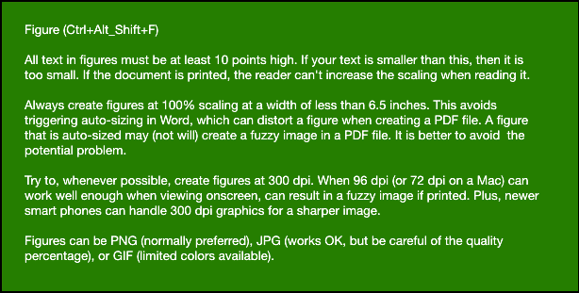
Yes, the figure caption goes on the top now. Glad you noticed.
Table 1. HDS Table (Caption Paragraph Style Added by Word Automatically When Adding Caption to Table)
Table Head (Alt+T) | Table Head (Alt+T)
Table Copy (Alt+C) | Table copy looks and works like Body Text in Word. After copying content to Framemaker, it works does not restart automatically number paragraphs. Please use this when adding a table in the middle of an ordered list.
Table Copy (Alt+C) | Table Copy (Alt+C)
Table 2. HDS Table Vertical
Table Head (Alt+T) | Table Copy (Alt+C)
Table Head (Alt+T) | Table copy looks and works like Body Text in Word. After copying content to Framemaker, it works does not restart automatically number paragraphs. Please use this when adding a table in the middle of an ordered list.
Table Head (Alt+T) | Table Copy (Alt+C)
Table Footnote (Alt+F)

Heading 1 (Ctrl+Alt+1)
Always follow a heading with at least one Body Text paragraph. Do not stack heading paragraphs. Explain what follows this heading in this heading.

Heading 2 (Ctrl+Alt+2)
Always follow a heading with at least one Body Text paragraph. Do not stack heading paragraphs. Explain what follows this heading in this heading.

Heading 3 (Ctrl+Alt+3)
Always follow a heading with at least one Body Text paragraph. Do not stack heading paragraphs. Explain what follows this heading in this heading.

Heading 4 (Ctrl+Alt+4) [Use very rarely]
Try to never use a Heading 4 paragraph. It is not normally considered good practice, although there are some rare cases when it is necessary.
Note — Use Important Note (Alt+I) rarely. If you use it regularly, it loses its importance. An important note always begins with “Note” (strong), a space, an m-dash (—, Ctrl+Alt+Minus sign on number keyboard), a space, and then the text. Do not use more than one paragraph in an important note. Do not follow and important note with another important note.
Character formats:
- Strong (Ctrl+B)
- Emphasis (Ctrl+I)
- Body Code (Ctrl+Alt+C). Only use this for user imput text. Do not use this for output from the computer in a command window. For example, use this style like the following:
Type the V-Vol name: VVOL1
When creating your document, do not worry about where something is placed on the page or adjusting the width of tables. All of this will change during the publishing process when importing your content to Framemaker. The editor will fix all of this when publishing.

